TEMPERANCE ELEMENTARY SCHOOL
School Crisis, Emergency Management and Medical Emergency
^{Response Plan}
July 2021
Confidentiality - The Amherst County Public Schools School Crisis, Emergency Management and Medical Emergency Response Plan is intended for official use only by the Amherst County Public Schools faculty & staff, county and state public safety and public health officials. Use of this plan for any purpose beyond its intended use is not authorized and could compromise the health and welfare of students, faculty and staff. Please report inappropriate use of this plan or any of its components as soon as possible to the school principal or the school division Emergency Manager.
Thank you for placing the safety of the Amherst County community first.

Personnel in Leadership Positions 2022-23 School Year:
Superintendent – Dr. William Wells
Assistant Superintendent – Dr. Dana Norman
Chief Operations Officer – Dr. Tim Hoden
Chief Student Services Officer – Mr. Josh Neighbors
Director of Human Resources – Mr. Jim Gallagher
Director of Accountability and Wellness - Ms. Marie Petrone
Supervisor of Maintenance and Operations - Mr. Gary Roakes
Supervisor of Transportation - Mrs. Rhonda Campbell
Supervisor of Technology - Mr. Joe Goldman
Supervisor of Student Data and Assessment – Mr. Kevin Harrison
Supervisor of Child Nutrition Program -- Mrs. Kim Klein
Chief Financial Officer - Ms. Kim Lukanich

Crisis Management Team Signature Page
This plan was developed through a collaborative process involving the following members of the Amherst County Public Schools crisis management team:
William Wells Craig Maddox
Superintendent Supervisor of History, CTE, ITRT,
and elective Programs
Tom McBride Lantz Martin
Assistant Principal Principal
Amherst County High School Temperance Elementary School
Wanda Smith Jennifer Bennett
Former Principal, Parent
Supervisor of Math, Science, Gifted, and Elective Programs
Lou Goldman Wayne Cocke
Amherst County Sheriff’s Office Director of Maintenance

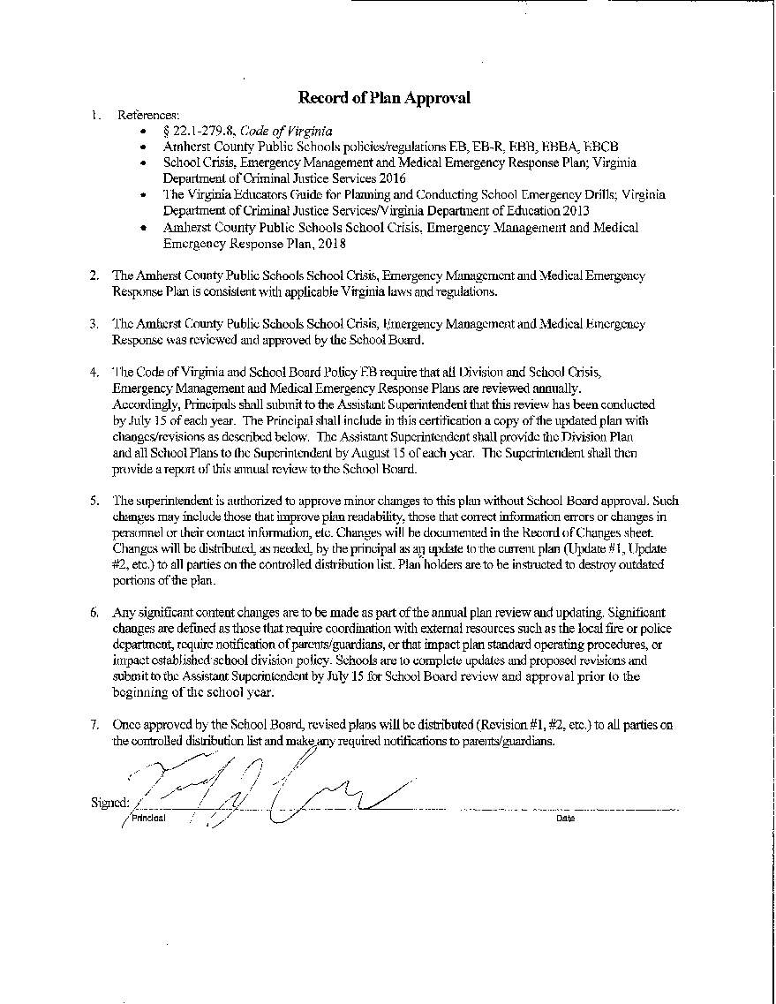

Record of Updates* to Plan

Date | Page(s) | Updates to Plan | Reason for Update
2/17/21 | 5 | Law Enforcement to Sheriff
 | 30 | Evacuation location – Gym Hallway
 | 31 | Evacuation location – Gym Hallway
 | 66 | Added the TES website
 | 67 | Updated Letter with TES
 | 68 | Updated all phone numbers & CMT members
 | 69 | Updated names & contact information
 | 102 | Updated phone numbers
 | 103 | Removed former employee & added  Sgt. John Ferguson
♦ Minor updates made by Emergency Manager/Principal will be incorporated, as necessary, into annual revision.
Record of Revisions* to Plan

Page(s) | Revisions to Plan | Reason for Revision | Effective Date
♦Revisions are reviewed and approved by School Board annually.
Necessary updates and revisions to this plan will be made whenever:
- Experience with crises or from exercises or drills reveal deficiencies or shortfalls.
- Community conditions impact school change.
- Applicable legal and/or regulatory requirements related to crisis management change.
Record of Distribution
Three versions of the [school] School Crisis, Emergency Management and Medical Emergency Response Plan are distributed.
Version Orange of the plan is intended for key leadership and those directly involved in the planning and implementation of this plan.
Version Gold is intended for [school] faculty and staff, or those that provide important supportive roles in the implementation of the plan.
Version Green is intended to inform parents and guardians of [school] students and selected other appropriate recipients.
Versions Orange and Gold contain information considered sensitive and requiring safeguarding including names and contact information of persons listed in this plan, key locations of people, assembly points, equipment, supplies, and facility operating devices. Persons holding copies of Versions Orange and Gold are expected to safeguard their copies of the plan and destroy obsolete plans.

Recipient Name, Title, Organization | Method of Distribution (print, electronic, both) | # Copies | Distributed by (Name) | Date
ORANGE VERSION (Comprehensive Plan - Controlled Version)
Superintendent's Office
Division Office, Emergency Manager
Principal
Division/School CMT members
Local Fire Department/EMS
Local Police Department/Sheriffs Office
Local Emergency Manager
Local Public Health Director/Coordinator
Mental Health Director/Emergency MH Services Coordinator
GOLD VERSION - Abbreviated Plan
School Faculty/Staff
Principal, Relocation School
GREEN VERSION - Plan Overview for Public Access
Parents/Guardians of students
President, Council of PTAs

TABLE OF CONTENTS
I. Introduction 1
A Purpose and Goal 1
B Authority for Plan 1
C Scope 2
D Concept of Operations 4
E. Crisis Management Team (CMT) 7
F Planning for Children with Special Needs and Disabilities……………………………………….……11
G Plan Maintenance…………………………………………………………………………….……11
II. Prevention and Mitigation 12
A Overview of Prevention and Mitigation 12
B Hazard Analysis and Risk Assessment 12
C Planning for Medical Emergencies 13
III. Preparedness 13
A Overview of Preparedness 13
B Incident Command System 14
C Emergency supplies and equipment 18
D Off-site Evacuation Areas and Routes 18
E. Staging Areas 19
F Training for Preparedness 19
IV. Response 20
A Overview of Response 20
B General Response Procedures 21
C Hazard/Incident/Medical Emergency Response 21
D Communications 22
E. Family Reunification, Information, and Assistance 24
F. Information for Parents Regarding Crisis Events………………………………………………………..24
F. Student Release Procedures for Staff……………………………………………………….………...…25
V. Recovery 25
A Overview of Recovery 25
B Physical/Structural Recovery 26
C Business Continuity 26
D Restoration of Academic Learning 26
E. Psychological/Emotional Recovery 26
VI. Incident/Emergency Response Protocols 27
A Overview of Responses 27
B General Response 27
Evacuation and Off-site Evacuation Procedures 27
Lockdown Procedures 30
Shelter-in-Place Procedures 33
C Threat- or Hazard-Specific Responses 35
Bomb Threats 35
Bus/Vehicle Crash 39
Demonstration 39
Intruder/Trespasser 40
Missing or Abducted/Kidnapped Student(s) 41
Missing Student with Cognitive Disabilities or Autism 42
Sexual Assault 44
Active Shooter 45
Weapon 46
D Natural Disasters/Weather-related Emergencies 47
Earthquake 47
Severe Weather 49
Tornado 50
High Winds 53
E Environmental Hazards 54
Fire/Explosion 54
Hazardous Materials Spill 55
Utility Failure 58
Terrorism 59
F Critical Incidents 60
Death or Serious Injury 60
Perceived Crisis 61
Suicide/Attempted Suicide 61
G Medical Emergencies 63
When to Call 911 63
Cardiopulmonary Resuscitation and Automatic Electronic Defibrillator Programs 64
Information for Parents Regarding Crisis Events 66
Appendix A. Contact/Notification Lists 68
Appendix B. Tools for Prevention and Mitigation 70
Appendix C. Tools for Preparation 74
Appendix D. Tools for Response 79
Appendix E. Tools for Recovery 81
Appendix F. Communications Tools .84
Appendix G. Logistical Tools (maps, photos, and diagrams) .88
Glossary .91
TES Campus Map .96
TES Fire & Emergency Diagram .97
TES Neighborhood Map .98
TES to Relocation Site .99
Relocation Site 100
TES Phone Tree 101
TES Team Member Information 102

I. INTRODUCTION
A. Purpose and Goal
The purpose of the Amherst County Public Schools School Crisis, Emergency Management, and Medical Emergency Response Plan is to establish a framework for emergency preparedness and response by specifying actions to be taken:
- Before an emergency to prevent, protect from, and mitigate the impact on life or property;
- During an emergency to respond to the emergency and minimize its impact on life or property; and
- After an emergency to recover from its impact on life or property.
The goal of the Plan is to ensure the safety of all members of the Amherst County Public Schools community through a rapid, coordinated, and effective response to and recovery from emergencies and disasters.
B. Authority for Plan
Virginia law requires that every school develop a written "school crisis, emergency management, and medical emergency response plan." Specifically, § 22.1-279.8, Code of Virginia, sets forth the following:
Definition of Plan
"School crisis, emergency management, and medical emergency response plan" means the essential procedures, operations, and assignments required to prevent, manage, and respond to a critical event or emergency, including natural disasters involving fire, flood, tornadoes, or other severe weather; loss or disruption of power, water, communications or shelter; bus or other accidents; medical emergencies, including cardiac arrest and other life-threatening medical emergencies; student or staff member deaths; explosions; bomb threats; gun, knife or other weapons threats; spills or exposures to hazardous substances; the presence of unauthorized persons or trespassers; the loss, disappearance or kidnapping of a student; hostage situations; violence on school property or at school activities; incidents involving acts of terrorism; and other incidents posing a serious threat of harm to students, personnel, or facilities. (§ 22.1-279.8(A), Code of Virginia)
School Board Responsibilities
"Each school board shall ensure that every school that it supervises shall develop a written school crisis, emergency management, and medical emergency response plan, consistent with the definition provided in this section, and shall provide copies of such plans to the chief law-enforcement officer, the fire chief, the chief emergency medical services official, and the emergency management official of the locality. Each school division shall designate an emergency manager." (§ 22.1-279.8(D), Code of Virginia)
"The local school board shall annually review the written school crisis, emergency management, and medical emergency response plans. The local school board shall have the authority to withhold or limit the review of any security plans and specific vulnerability assessment components as provided in subdivision 4 of § 2.2-3705.2" (§ 22.1-2.79.8(D), Code of Virginia)
School Superintendent Responsibilities
"The local school division superintendent shall certify this review in writing to the Virginia Center on School Safety no later than August 31 of each year." (§ 22.1-279.8(D), Code of Virginia)
Other Related Laws and Regulations
Virginia laws require schools to conduct fire drills, tornado drills, and lock-down drills (§ 22.1-137, § 22.1-137.1, § 22.1-137.2) and to report certain violations of law and of student codes of conduct. (§ 22.1-279.3:1).
Virginia Board of Education Regulations address the safety of school facilities, specifying multiple health and safety practices (8VAC20-131-260).
The Amherst County Public Schools School Crisis, Emergency Management, and Medical Emergency Plan was developed in accordance with Code of Virginia § 22.1-279.8. The Plan also conforms with requirements for fire drills, tornado drills, and lock-down drills and proper reporting of violations of law and the student code of conduct.
C. Scope
This Plan focuses narrowly on specifying actions in preparing for, responding to, and recovering from school crises and emergencies. The Plan complements and is best understood in conjunction with other school division plans and procedures related to school safety, school security, threat assessment, suicide prevention/intervention, bus safety, and general procedures for medical treatment of students. The Plan does not duplicate information contained within the other plans and procedures, but cross-references them.
Numerous prevention and mitigation measures being implemented by the school division/school are set forth in the following related Plans and Procedures.
Amherst County Public Schools School Bus safety Program (Policy EEAC)
Amherst County Public Schools Suicide Prevention Procedures (Policy JHH)
Amherst County Public Schools Threat Assessment Procedures (Policies EBB and EBB-R1)
Amherst County Public Schools Visitors Procedures (Policies KK and KK-R)

Amherst County Public Schools Safety Plan contains information on safe practices on and off school property; transportation/bus safety; and required safety training for students and staff. It was developed in collaboration with public safety and public health officials and risk management consultants. The Plan is available upon request from the Superintendent's Office.
This Plan is organized around the four phases of emergency management: 1) Prevention/Mitigation; 2) Preparedness; 3) Response; and 4) Recovery. For purposes of this Plan, school crises are organized into three categories:
1. “Crisis incidents” include situations that do not occur on school property or at a school event but negatively affect schools and to which schools must respond, but typically do not require and emergency response. Examples include death of a student, school personnel, or a member of a student’s immediate family by suicide, illness, or accident; non-school incidents injuring or victimizing a student or staff member; perceived crises such as tensions arising from racial incidents and rumors of potential violence between rival students. School administrators, guidance counselors, and other student services professionals typically have primary responsibilities in responding to crises incidents. The school principal shall have the discretion to determine what qualifies as a crisis incident and when to convene the Crisis Management Team.
2. “Critical incidents” are events that require an immediate response by public safety agencies and are managed by school administrators only until public safety officials arrive. They typically involve activation of a school Crisis Management Team. Critical incidents include, but are not limited to, natural and technological disasters and security emergencies that adversely affect the normal operation of the school. Examples include tornadoes, severe thunderstorms/weather incidents, terrorist attacks, fire, hazardous material spills, school shootings, situations involving hostage and/or kidnapping, threats involving weapons, explosions, criminal activity or the threat of criminal activity, and fugitives/suspects being pursued near a school by law enforcement. A critical incident could also include injury or death of a student, teacher, or school personnel, whether on or off campus.
3. “Medical emergencies” are those possibly life-threatening situations arising from health conditions as well as unintentional and intentional injuries. Examples include cardiac arrest, serious illness or condition, drug overdoses, seizures, playground accidents and serious athletic injuries, and acts of violence (assaults) that require emergency medical treatment. School administrators, school nurses, and local emergency medical personnel typically have primary responsibilities in responding to medical emergencies. Drug overdoses and acts of violence will also require law enforcement involvement.

Framework for School Crisis Management
Type of Crisis | Description | Examples | Who Typically Manages
Crisis Incidents | Situations that do not occur at school but negatively effects schools | Student or staff death, suicide, accident or perceived crisis | School Administrators and student services staff
Critical Incidents | Events that require an immediate response. | Threats involving weapons, fire, natural disasters, student or staff death, accident. | Public safety agencies or school administrators.
Medical Emergencies | Situations arising from health conditions as well as unintentional and intentional injuries. | Serious illness or medical conditions; drug overdoses; serious injuries. | School nurse and local EMT.
It is recognized that a critical incident or medical emergency can vary in scope and intensity. Situations can range from a non-emergency school crisis involving a single student to a life threatening situation affecting the entire school division. Incidents and emergencies can occur before, during or after school hours; on or off school property.
D. Concept of Operations
The Amherst County Public Schools Plan has been developed in collaboration with and is coordinated with all appropriate public health and safety agencies within Amherst County and with state and federal emergency operations plans. The planning process has been informed by appropriate hazard analyses and risk assessments and addresses actions taken before an emergency to prevent, protect from, and mitigate the impact on life or property, actions to be taken during an emergency to respond to the emergency and minimize its impact on life or property, and actions taken after an emergency to recover from its impact on life or property.
Collaboration with public health and safety agencies continues for the purpose of further developing and implementing strategies to mitigate, prevent, prepare for, and in the event of an incident, respond to, and effectively recover and restore the safety and security to the school community. Amherst County Public Schools maintains agreements with the following agencies to assist in planning, training, emergency response and recovery:

Amherst County Fire and Rescue Department
Amherst County Sheriff’s Office
Town of Amherst Police Department
Virginia State Police
Amherst County Health Department
Amherst County Community Services Board
Amherst County Department of Human Services
American Red Cross
IV. Emergency Services: Call 911
Coverage Area
School | Rescue | Fire | Law Enforcement
Amelon Elementary | Monelison | Monelison | Sheriff
Amherst Elementary | Amherst | Amherst | Sheriff
Amherst High | Amherst | Amherst | Sheriff
Amherst Middle | Amherst | Amherst | Sheriff
Central Elementary | Amherst | Amherst | Sheriff
Elon Elementary | Monelison | Monelison | Sheriff
Madison Heights Elem. | Monelison | Monelison | Sheriff
Monelison Middle | Monelison | Monelison | Sheriff
Amherst Education Ctr | Monelison | Monelison | Sheriff
Temperance Elem. | Pedlar | Pedlar | Sheriff
Temperance Elem. | Roseland | Piney River | Sheriff

Law Enforcement:
Town of Amherst 946-7885
Sheriff’s Department 946-9300 (946-5517, if no answer)
State Police: 1-800-552-0962
Central Virginia Crime Stoppers 1-888-798-5900
Sweet Briar – Director, Brian Marker 381-6244 (or 381-6144)

Rescue Squad Fire Department
Amherst 946-5055 946-7915
Monelison 929-0908 929-3115
Pedlar 922-7433 922-7433
Piney River/Roseland 1-434-263-7050 1-434-263-7050

V. Available Resources
- Amherst County Public Schools
- Maintenance
Gary Roakes 946-9709 Cell 841-4279
24 hr Cellular 841-6786
- Transportation
Rhonda Campbell 946-9707
- Director of Student Services
Josh Neighbors 946-9341
- School Psychologists
Shannon Abatecola (office at Central Elementary) 946-9700
Martha Anderson (office at ACHS) 846-2898
Jeff Williams (office at Monelison) 846-1307

- Supervisor of Accountability and Student Wellness
Marie Petrone 946-9700
- County Agencies
- Amherst Department of Social Services 946-9330
- Amherst County Mental Health 946-2316
- Amherst County Health Department 946-9408
- Sam Bryant, Public Safety Director 946-9307
- TBA, Public Safety Deputy Director 946-9307
- Referral Agencies
- Virginia Baptist Hospital Assessment Center 947-4444
- Lynchburg General Hospital Emergency Mental Health 947-3033
- Lynchburg General Hospital Emergency Room 947-3126
- Other
- Employee Assistance Program – Bob Conlon 845-1246
- Poison Control Center (Blue Ridge) 1-800-451-1428
- Central Virginia Crime Stoppers 1-888-798-5900

E. Crisis Management Team (CMT)
For School Division Plan
A primary mission of the school division Leadership Crisis Management Team (LCMT) is to support the school-level CMT/ICS in effectively responding to crises. At the school division level, when there
is a community wide, multi-school disaster or crisis event, the school division LCMT will work in tandem with public safety and public health officials to ensure a coordinated and effective response.
Areas of responsibility for the Amherst County Public Schools Leadership Crisis Management Team (LCMT) are shown below:
Amherst County Public Schools Crisis Planning and Response Team
Areas of response at the school division level may be conceptualized as
represented below:
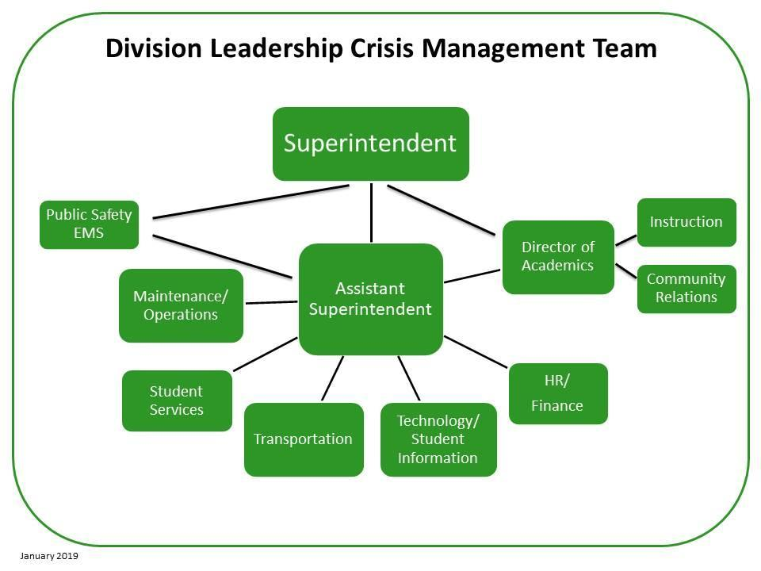

The Superintendent will have oversight of all Crisis Management Operations. The Superintendent shall have the responsibility to:
- Authorize the release of information to the public.
- Keep the School Board and other local officials informed of the status of the emergency.

The designated Emergency Manager, in collaboration with the Superintendent and other senior administrators, shall have responsibility to:
- Direct all operations of the school division in the management of the emergency, except where others have authority that supersedes the designated emergency manager (i.e. a public safety official acting in an official capacity).
- Gather information from all aspects of the emergency for use in making appropriate decisions about the management of the emergency.
- Assess the immediate situation and assign tasks based on the overall needs for managing the emergency.
- Stay in contact with the leaders of the emergency service agencies and the law enforcement agencies working the emergency.
- Receive state and local officials who come to help or gather information.
- Establish and maintain lines of communication between the division and the emergency site; for off-campus emergency, lines of communication must be established for the involved school, as well. Such lines of communication may also include couriers.
- Communicate with other schools in the division during the emergency period.
- Assign resources (persons and materials) to various sites for specific needs. This may include the assignment of school personnel from other school or community sites such as community emergency shelters.
- Authorize immediate purchase of outside services and materials needed for the management of emergency situations.
The Supervisor of Student Services shall:
- Implement plan for crisis; authorize and coordinate back-up student support personnel from other schools to assist, as needed, at crisis site(s).
- Maintain active file of helping agencies within the community including the names of contact person(s).
- Create letters to notify parents of continuing care that is available to students; available care will include local and state agencies, as well as school-based care.
- Develop information sheet for parents, teachers, and others; information will include topics such as the impact of crises on students, signs of stress, and guidelines for dealing effectively with crisis-related stress.
- Assist with planning and conducting parent/community meetings for information dissemination and recovery activities.
- Maintain follow-up activities such as referrals for help outside the school services setting.
- Confer with full staff and faculty; assist in coordination of briefings for staff and faculty.
- Make recommendations regarding the restarting of school and schedule of activities for the day after the crisis.

The Director of Academics shall:
- Report immediately to the local hospital if students or adults are being sent to that hospital for treatment. If more than one hospital is admitting students or adults, coordinate the communication among those hospitals and the school division. Assign and direct other division staff to assist at those hospitals.
- Coordinate communication between the hospital and the division office.
- Meet and talk with the parents of students and spouses of adults who have been admitted to the hospital.
- Collect and disseminate information to the media. Be aware of deadlines, the need for
information accuracy, and other issues related to the media and the performance of their jobs.
- Plan and coordinate press interviews to help the news media meet deadlines.
- Create and disseminate press releases as approved by the superintendent
- Respond to rumors through the dissemination of accurate information. Organize a network of key people within the community through which accurate information can be disseminated.
- Plan and coordinate the use of the division’s social media networks for live and taped presentations. Press conferences can go out live; updates for the public can be taped and aired as needed.
- Coordinate information to be shared with school and division personnel during and after the crisis.
- Act as a liaison between the media and division personnel whose attention must be focused on the immediate problems of managing the crisis without constant interruption.
- Arrange interviews for the media with key school and division staff who are involved in the emergency or who act as spokespersons for the division.
- Establish and maintain a clearinghouse for calls and requests from schools, the community, parents, and the media and refer those to the appropriate person or place.
The Supervisor of Maintenance and Operations shall:
- Coordinate with transportation coordinator as needed.
- Serve as a liaison between the emergency school site and the emergency support teams that may be needed.
- Coordinate and direct communication between the emergency site and county and state agencies.
- Obtain and direct the placement of generators when power must be restored for a temporary period.
- Coordinate and direct the acquisition of water when there is a disruption of water and sewer services.
- Coordinate and direct contact with emergency medical services, local police and sheriffs’ departments, fire departments, and the state police.
- Coordinate and direct search-and-rescue operations when needed.
- Arrange for the delivery of outside services and materials needed for the management of the emergency.
- Plan and initiate arrangements for food for building personnel.
The Supervisor of Transportation shall:
- Establish and maintain school division protocols for transportation-related emergencies.
- Provide division wide transportation for bus drivers.
- Establish and maintain plans for the emergency transport of students and school plans (a chemical spill for example).
- Coordinate transportation plans with State Police and other law enforcement personnel, as appropriate.
The Supervisor of Technology and Supervisor of Student Data and Assessment shall:
- Coordinate use of technology.
- Assist in establishment/maintenance of emergency communications network. Assist in obtaining needed student and staff information from the computer files.
- Prepare and maintain an emergency kit that contains floor plans, telephone line locations, computer locations, and other communications equipment.
- Establish and maintain computer communication with the central office and with other agencies capable of such communication.
- Establish and maintain, as needed, a stand-alone computer with student and staff database for use at the emergency site.
- As needed, report various sites involved in the communication system if there are problems in that system.
The offices of Finance and Human Resources shall:
■ Ensure that personnel in schools have adequate materials and resources to address crises.
- Play important roles in after action report production, particularly relative to personnel placement and needs.
- Be available to assist other offices as needed during crisis response.
- Review continuity of salary and benefits when incidents, or the after effects of incidents, may impact payments.
- Be aware of the requirements of the Freedom of Information Act and provide all
appropriate information based on those requirements.

The office of Instruction shall:
- Conduct a debrief with teachers and faculty post-crisis to identify deficits and obstacles, then communicate summary information to crisis managers.
- Be available to assist other offices as needed during crisis response.
Articulation of Responsibilities
To prevent role confusion, clearly identify responsibilities, and differentiate task assignment, all expectations and responsibilities should be in writing as part of the emergency operation plan. Each office and designee should have a written copy of their responsibilities.
Schools as Disaster Shelters
During a large-scale disaster, there is some likelihood that schools may be used as community shelters. When such circumstances arise:
■ The school principal will coordinate use of the school resources.
- The school nurse will coordinate with outside medical agencies for their provision of medical oversight of shelter clients with chronic conditions.
- The food service coordinator will coordinate with the Shelter Manager for an orientation on food service supplies, equipment, and operations.
- The school principal/designee will coordinate for use of portions of the school as a pet shelter.
- Other assignments and coordinating instructions are contained in a Memorandum of Understanding with the local chapter of the American Red Cross.
For School Plan
The school crisis management team is led by the principal who shall designate an alternate to act in the principal’s absence. Members of the CMT include teachers, school counselors, the school nurse, school psychologist and/or school social worker, school secretary, custodian/building engineer, and School Resource Officer.
Responsibilities of the school CMT include:
- Developing site-specific protocols for responding to specific types of crises.
- Assuming assigned responsibilities within a school incident command system.
- Assuming leadership roles in orienting staff to procedures and training to fulfill designated roles, including conducting tabletop simulations and practice drills.
- Providing information to students, staff, and community on crisis management referral procedures.
- Providing assigned leadership roles in recovery activities following a crisis or disaster.
- Conducting debriefing at the conclusion of each crisis episode to critique the effectiveness of
the building’s Crisis Management Plan.
- Conducting periodic reviews and updating of the school Crisis Management Plan and
conducting related updated staff training.
A roster of school CMT members with current contact information is maintained on an ongoing basis. The Roster of CMT Members is a part of Appendix A. Contact/Notification Lists.
Additional CMT roles and responsibilities are listed under Incident Command System (ICS). See section III. Preparedness. Each school CMT should periodically coordinate with the school division team (as appropriate).
F. Planning for Children with Special Needs and Disabilities
Amherst County Public Schools is committed to meeting the needs of all students in the event of an emergency, including those with special needs and disabilities. School CMTs take into consideration the needs of these students throughout the four phases of crisis management by consulting with disability specialists to identify students’ needs; build on appropriate accommodations, modifications, and services; teach students crisis response strategies; and ensure that adults, including first responders, are trained to follow established protocols. Specific accommodations and services are included in Appendix D. Tools for Response.
G. Plan Maintenance
Development of a crisis management plan is not a one-time task. Changes – in personnel, policies, resources, and conditions – occur and require plans to be updated and refined. All school crisis plans are formally reviewed and updated, as needed, on an annual basis.
II. PREVENTION AND MITIGATION
A. Overview of Prevention and Mitigation
The prevention-mitigation phase is designed to assess and address the safety, security and integrity of school buildings, learning environments and students and staff.
“Prevention” is any step that schools can take to decrease the likelihood that an incident will occur. Examples of prevention activities include:
- Conducting comprehensive, strength-based vulnerability assessments—of school buildings and grounds, school cultures and climates, staff skills, and community resources—to help crisis response teams identify, analyze and profile hazards and develop appropriate policies and procedures;
- Establishing communication procedures for staff, parents, students and the media; and
- Enforcing policies related to food preparation, mail handling, building access and student accountability.
“Mitigation” is any sustained activity that schools take to reduce the loss of life and damage related to events that cannot be prevented. These activities may occur before, during, or after an incident. Examples of mitigation activities include:
- Fencing hazardous areas;
- Anchoring outdoor equipment that could become flying projectiles in high winds; and
- Bolting bookshelves to walls and securing loose wires.
Numerous prevention and mitigation measures being implemented by the school division/school are set forth in other Plans and Procedures related to school safety, school security, threat assessment, suicide prevention/intervention, bus safety, and general procedures for medical treatment of students. The most relevant are listed in section I. C. Scope.
B. Hazard Analysis and Risk Assessment
Hazards are conditions or situations that have the potential for causing harm to people, property, or the environment. The Amherst County Public Schools CMT has conducted a hazard vulnerability and risk assessment to determine the strengths and weaknesses of their individual building and grounds; the school’s social, emotional, and cultural climate; community and staff resources; and the unique concerns of individuals with disabilities and special needs.
Hazards can be classified into three categories: natural, technological, and school specific-hazards.
Data from the Amherst County Emergency Operations Plan identified the following primary hazards as having greatest impact on the school community: flooding, drought, hurricanes, severe winter weather, land subsidence/karst, tornado, wildfire, landslide, terrorism, earthquakes, tornadoes, hazardous materials incidents, power failures, essential shortages, and transportation accidents.

Emergency response procedures in the event of natural and technological hazards are contained in section VI. Incident/Emergency Response.

School-Specific Hazards
School-specific hazards have been identified from reviews of school division/school Discipline, Crime, and Violence data, annual safety audits, applicable school climate surveys, and crime incident data for the surrounding community/neighborhoods
Hazards and threats are addressed in this Plan and emergency response procedures for all identified school-specific hazards are contained in section VI. Incident/Emergency Response.
C. Planning for Medical Emergencies
A School Medical Emergency Response Plan (MERP) has been developed for each school in Amherst County Public Schools. Plans are tailored to the schools’ unique needs and resources are developed as part of the school division’s crisis plan. Planning has involved assessing needs, equipping schools, establishing protocols, staff training, and plans for documenting and evaluating response.
Students with Special Needs
Children and adolescents with special health care needs including those with chronic physical, developmental, behavioral, or emotional conditions or at risk for developing those conditions typically require an Individualized Education Program (IEP), an Individual Health Care Plan (IHCP), and/or an Emergency Care Plan (ECP) to meet their health needs. ECPs are prepared for students with health conditions, physical disabilities or communication challenges who have been identified as requiring special assistance during emergencies.
Automatic Electronic Defibrillators
All schools have been equipped with automatic electronic defibrillators (AEDs) and multiple staff in each school trained to respond to a life-threatening emergency, including operation of AEDs.
III. PREPAREDNESS
- Overview of Preparedness
Preparedness readies the school division/school to respond in a rapid, coordinated and effective manner
to an emergency.
Elements of preparation planning addressed here are:
- Establishing the Incident Command System;
- Preparing emergency supplies and equipment;
- Designating off-site evacuation areas and routes;
- Designating and preparing CMT/ICS Command Post;
- Designating and preparing staging areas for transportation, parent reunion/assistance, and media; and
- Implementing functional training exercises and drills for faculty and staff with first responders.

B. Incident Command System
Amherst County Public Schools has adopted the National Incident Management System (NIMS) for planning and responding to emergency situations and uses an Incident Command System (ICS) to address critical incidents and/or crises when multiagency response is required. All schools are required to use NIMS and ICS for incident management.
The organization and responsibilities of the Amherst County Public Schools LCMT are described in section I. E. Crisis Management Team.
Public Safety and Non-school Personnel Roles
Roles and responsibilities of key public safety and non-school personnel within the ICS are:
Law Enforcement Commander – Integrates school and law enforcement training and response plans. Works with the school CMT/ICS to carry out the response and secure the incident scene by keeping parents and community members away from the school. Assumes role of Incident Commander once school is evacuated and it is ascertained that a criminal act has occurred. Ensures clear passage of emergency service vehicles.
Fire Chief – integrates school fire and hazardous material response plans. Works with the school CMT/ICS in responding to the emergency. Remains on standby at the perimeter of scene unless a fire or hazardous material emergency develops, at which time the Fire Chief or designee becomes the Incident Commander.
Emergency Medical Services Chief – During planning helps to identify school and community members who have CPR and other emergency medical skills. Works with the School Nurse to coordinate the delivery of medical treatment during an emergency.
Mental Health Services Coordinator – Works directly with the School Counselor and the principal to coordinate appropriate interventions before a crisis, consultation during a crisis, and recovery efforts after a crisis.
Emergency Management Director – Provides technical advice to the CMT/ICS on planning, training and exercising of an all-hazards emergency management plan. Establishes and operates the town Emergency Operations Center; manages local resources needed in response to a school incident; and is the conduit through which additional resources are requested.
CERT (Community Emergency Response Team) – Coordinates CERT augmentation to the school CMT/ICS and/or public safety committee during school emergencies. Reports to the Staff Assignments Leader when activated.
INCIDENT COMMANDER
The ICS is organized as shown below. Each member of the school CMT is assigned a role in the ICS. A Roster of ICS Assignments is a part of Appendix A. Contact/Notification Lists.

INCIDENT COMMANDER
STUDENT ACCOUNTING
TRANSPORTATION/
GO-KIT LIAISON
OFF-SITE EVACUATION
PARENT REUNION ORGANIZER
INFORMATION/MEDIA
SCHOOL SITE SECURITY
TEACHERS WITH STUDENTS
STAFF ASSIGNMENTS
Communications Recorder

TEACHERS NOT
ASSIGNED STUDENTS
POLICE/FIRE LIAISON
COUNSELING

NOTE: The principal or his/her designee is the Incident Commander (IC) for school emergencies until public safety officials assume that role. Incident Commander and Incident Supervisor represent the same position—ICS designations recommend use of Incident Commander.
The IC role officially passes to the fire chief during fire/HAZMAT incidents and to the law enforcement commander following a criminal act, after the principal briefs the public safety official on the situation. To affect a smooth transfer, schools always involve local first responders in the school's emergency management plan development and training.
Although a public safety official may have assumed the IC role, the principal maintains the leadership role related to the school staff and students and the various functions that they have been assigned.
During emergencies where a single Incident Commander is not appropriate, the principal and public safety officials form what is called a "Unified Command," where the principal and public safety officials share in the decision-making process.
ICS Roles, Duties and Responsibilities
Incident Commander
As the highest level executive in the school, he or she provides leadership for the development and execution of the Crisis Plan. Verifies crisis and initiates activation of the CMT.
- Establishes a command post. Makes decisions based on information/suggestions by CMT members.
- Relinquishes overall incident leadership role to fire officials during a fire/hazardous materials incident and/or to the ranking law enforcement officer following a criminal act. May assume leadership role within a "unified command" structure with responding agencies.
- Provides notifications to applicable Leadership Team member(s) or department(s).
Police/Fire Liaison
Provides information to local law enforcement and fire and rescue department personnel about what has taken place and the plans the school has implemented to ensure the safety of the students.
- Maintains contact with police/fire operations throughout the incident.
- During some incidents, the Incident Commander can accomplish this liaison assignment; however, a large incident should have someone whose sole responsibility is to act as a liaison.
Off-Site Evacuation
- Organizes use of off-site location to include: selecting evacuation routes, planning the safe movement of students to the location; assisting with student accounting once they are moved; planning for the movement of special needs students and staff.
- Coordinates with Incident Commander, Transportation, Student Accounting and Parent Reunion Organizer to manage the move and parent reunification process.
Parent Reunion/Information/Assistance Organizer
- Organizes, manages and coordinates the safe and orderly release of students to their parents/guardians during a school emergency.
- Establishes pre-identified location where parents can wait to be reunited with their children; answers procedural questions; calms anxious parents and provides information concerning the emergency.
- Coordinates with Incident Commander and Information Media representative concerning the notification of parents and release of information to parents. Also coordinates with Police/Fire Liaison and Student Accounting, as necessary.
Counseling
- Plans, organizes and provides crisis intervention and prevention counseling.
- Coordinates post-event counseling program to help students, parents, faculty, and the community to recover from an incident.
- Coordinates professional community services, when required.
Communications/Recorder
- Confirms that 911 has been called.
- Documents events as they occur, including decisions and actions taken with time annotations.
- Makes notifications, orders resources and provides informational updates as directed by the Incident Commander.
- Assists Incident Commander with monitoring communication devices.
Information/Media
- Establishes the media staging area. Ensures media doesn't gain access to student or faculty during the incident.
- Controls rumors by providing school staff with information about the incident.
- Assists Amherst County Public Schools disseminate information as directed.
Transportation/Go-Kit Liaison
- Transportation/Go-Kit Liaison: Organizes, manages and coordinates off-site evacuation transportation services, as well as early or late releases with the Amherst County Public Schools transportation representative.
- He or she is responsible for maintaining, updating and removing the Go-Kit from the building and ensures that the medical Go-Kit is removed from the school during an emergency.
- Coordinates with Off-site Evacuation Organizer and Incident Commander.
Student Accounting
- Ensures that all teachers have an accurate accounting of students.
- Coordinates efforts in accounting for missing and extra students.
- Coordinates with Incident Commander and Parent Reunion Organizer as necessary.
School Site Security
- Assesses crisis and evaluates student and staff safety.
- Initiates protective security measures to separate students and staff from threat, if necessary.
- Assists student and staff and maintains safety, order and discipline.
- Prohibits media representative(s) contact with students. Coordinates with CMT members, as needed.
Teachers and staff not assigned to a class when an emergency occurs
- Report to the Staff Assignments Leader if not previously assigned an emergency role. These staff members will prepare backpack letters and/or place or receive large volumes of calls to or from parents, community partners, etc., about an incident.
- They will also augment the School CMT when communicating messages to faculty, staff and students throughout the school when timeliness is of the essence and electronic means are inoperable.
Teachers with students in class
- Provide supervision of students in their care and remain with students during emergencies until directed otherwise.
- Ensure safety of students; direct students according to response procedures; render first aid when needed; manage student communication via cell phones per school policy; report missing/injured or extra students to the Student Accounting Leader.

